**What has been Accomplished so far:**

We’ve accomplished a number of things for our project lately. First, we’ve secured a domain and hosting for future publishing of our tool and have decided on a LAMP/WAMP stack, giving us access to PHP and mySQL for our backend; this helps take out the guessing of the libraries we need to interact with the API. Secondly, we’ve made substantial progress on the front end, completing more pages and layouts, while also deciding on ways to unify the looks of them all. We very much expect this to be completed on time and only need minimal adjustments over the course of development.

**What we are behind on:**

Logging in with Twitter remains as an issue. Ian is working his way through the issue and is in the process of creating a bridge between a PHP backend (via the TwitterOAuth library) and Javascript frontend on a local WAMP server. Admittedly, lack of familiarity with these technologies is causing the most issues at this point, and he’s making progress in other areas when stuck.

**What we are ahead on:**

As it stands we’ve made even more work on the front end, adding polish here and there and started some small work with jQuery in a couple branches so that our site can be dynamic. Currently, we’re in a push to make iterations over our pages and unify their designs. Most of frontend work is completed and the settings page has had progress made. As such, we will be moving on to the backend work a week earlier than predicted.

**Whats next:**

Our next steps will be to finish the visual aspects of the UI and utilize jQuery to modify the layout dynamically by loading in and modifying the various pages/elements we’ve created. This next push will largely include the completion of our social media-specific pages, as well as the creation of user experience elements like a home page and first-time page where it gives you login options. Naturally of course, Twitter login will continue to be a top priority during this time as we approach our next sprint. We will also begin on the backend through grabbing facebook timeline data.

**Photos:**

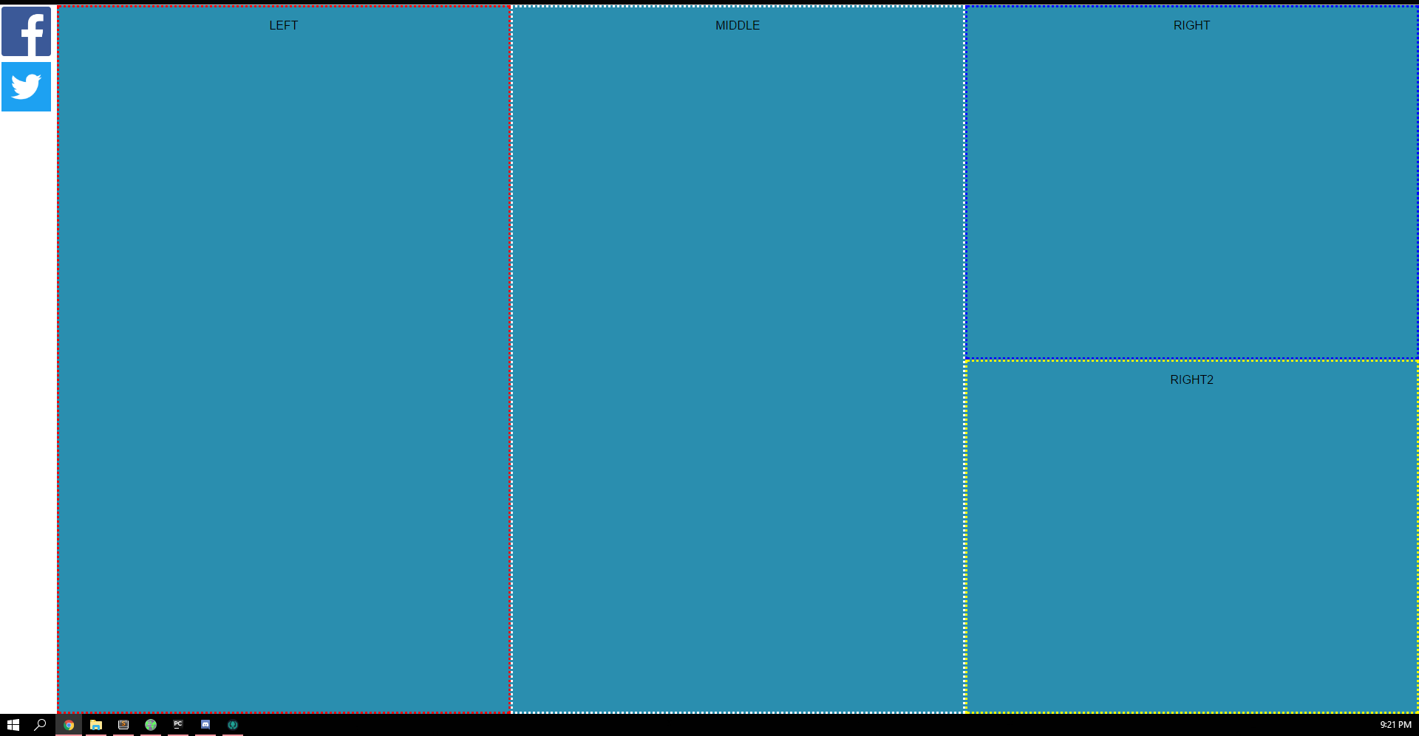

*The Home Page (Borders are just for show)*

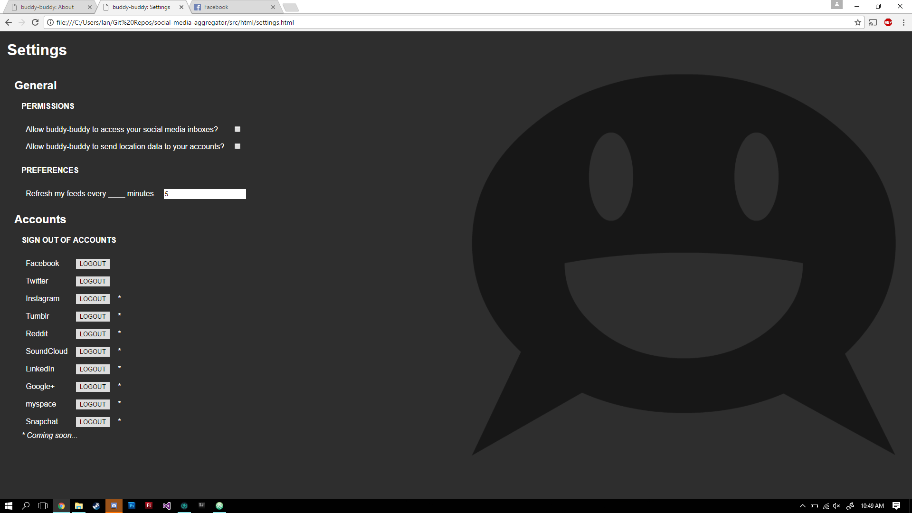

*Settings Page (first draft)*

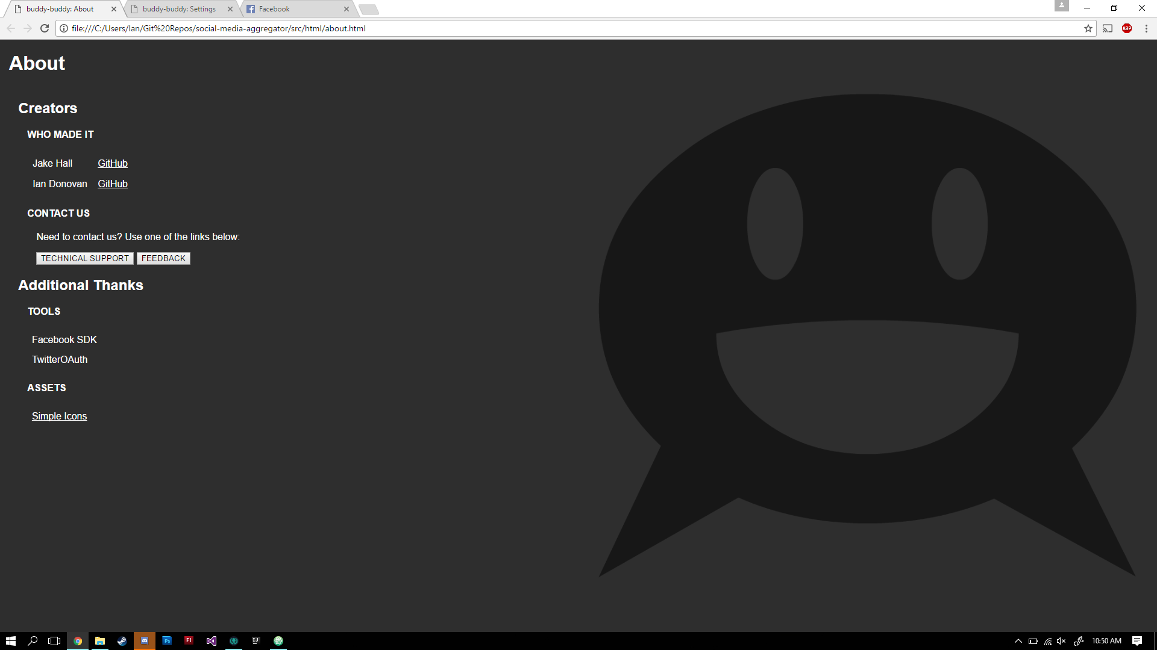

*About Page (first draft)*

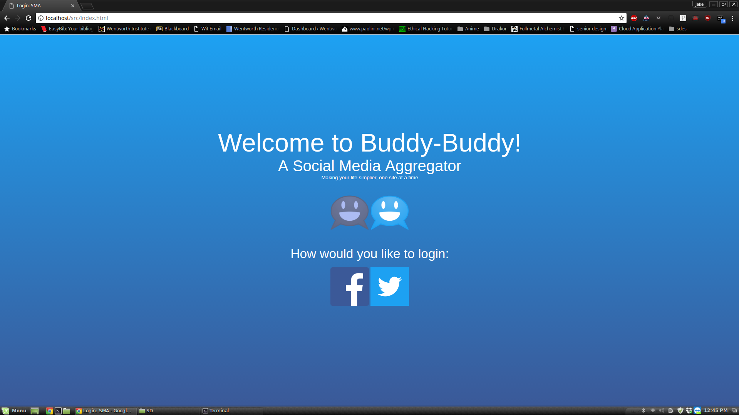

*The General Login Screen*

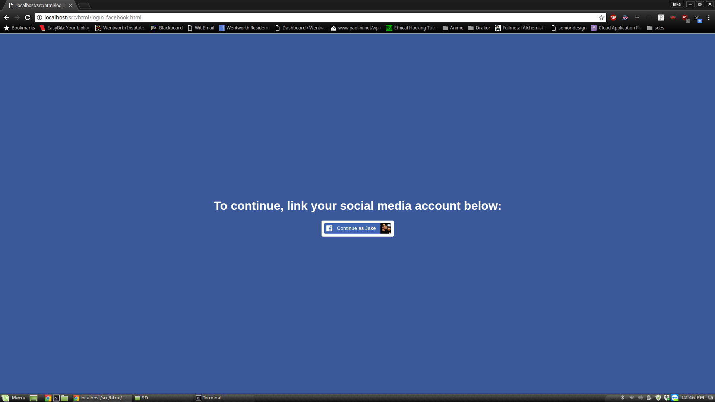

*The Facebook Specific Login Page*

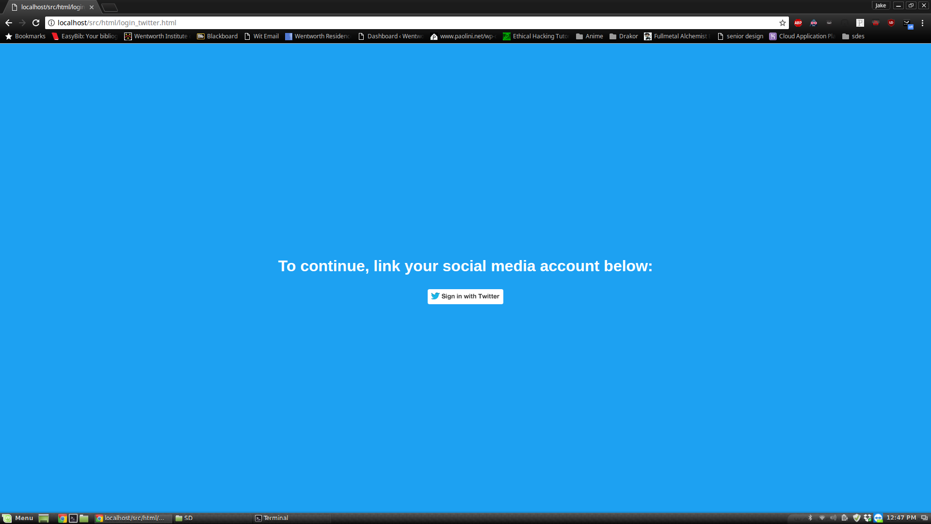

*The Twitter Specific Login Page*

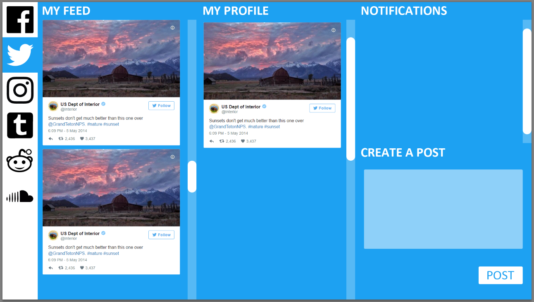

*Twitter Home Screen Mockup*